**MULTIPLE PROCESSOR ORGANIZATIONS**

Types of Parallel Processor Systems

A taxonomy first introduced by Flynn [FLYN72] is still the most common way of categorizing systems with parallel processing capability. Flynn proposed the following categories of computer systems:

**Single instruction, single data (SISD) stream:** A single processor executes a single instruction stream to operate on data stored in a single memory. Uniprocessors fall into this category.

**Single instruction, multiple data (SIMD) stream**: A single machine instruction controls the simultaneous execution of a number of processing elements on a lockstep basis. Each processing element has an associated data memory, so that instructions are executed on different sets of data by different processors. Vector and array processors fall into this category, and are discussed in Section 18.7.

**Multiple instruction, single data (MISD) stream**: A sequence of data is transmitted to a set of processors, each of which executes a different instruction sequence. This structure is not commercially implemented.

**Multiple instruction, multiple data (MIMD) stream**: A set of processors simultaneously execute different instruction sequences on different data sets. SMPs,clusters, and NUMA systems fit into this category.

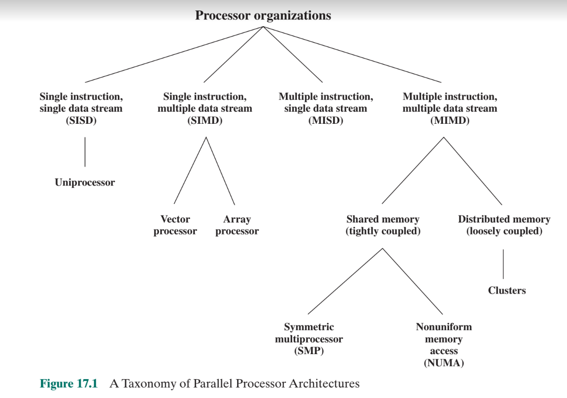

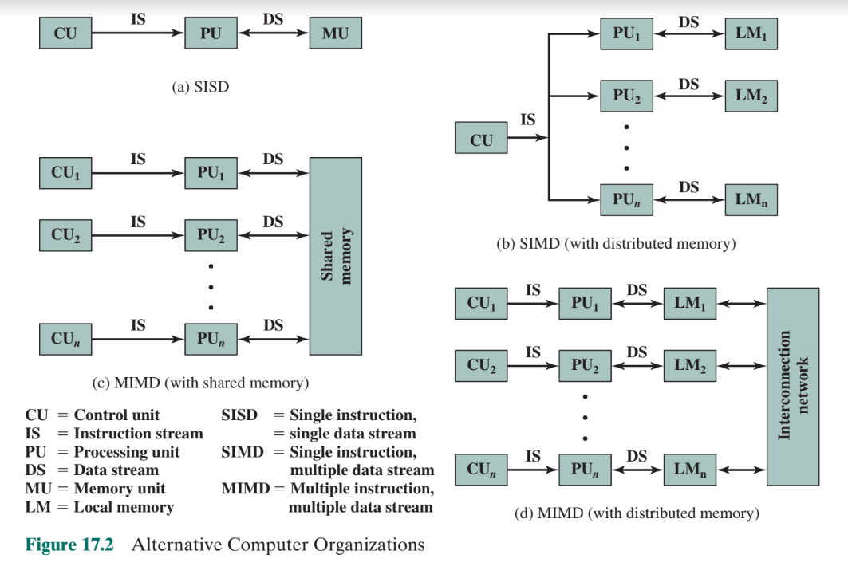

**SYMMETRIC MULTIPROCESSORS**

Until fairly recently, virtually all single-user personal computers and most workstations contained a single general-purpose microprocessor. As demands for performance increase and as the cost of microprocessors continues to drop, vendors have introduced systems with an SMP organization. The term SMP refers to a computer hardware architecture and also to the operating system behavior that reflects that architecture. An SMP can be defined as a standalone computer system with the following characteristics:

1. There are two or more similar processors of comparable capability.

2. These processors share the same main memory and I/O facilities and are interconnected by a bus or other internal connection scheme, such that memory access time is approximately the same for each processor.

3. All processors share access to I/O devices, either through the same channels or through different channels that provide paths to the same device.

4. All processors can perform the same functions (hence the term symmetric).

5. The system is controlled by an integrated operating system that provides interaction between processors and their programs at the job, task, file, and data element levels. An SMP organization has a number of potential advantages over a uniprocessor organization, including the following:

**Performance:** If the work to be done by a computer can be organized so that

some portions of the work can be done in parallel, then a system with multiple

processors will yield greater performance than one with a single processor of

the same type (Figure 17.3).

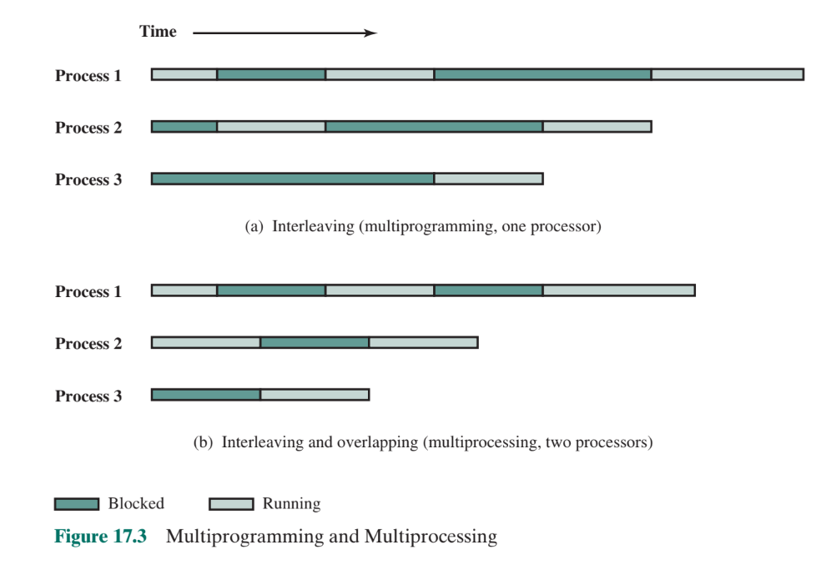

**Availability**: In a symmetric multiprocessor, because all processors can per- form the same functions, the failure of a single processor does not halt the machine. Instead, the system can continue to function at reduced performance.

**Incremental growth:** A user can enhance the performance of a system by adding an additional processor.

**Scaling**: Vendors can offer a range of products with different price and performance characteristics based on the number of processors configured in the system.

